# Topic

Explore over 3.5 million monthly domestic flight records from 1990 to 2009 using Plotly, Leaflet, SQL, HTML/CSS, D3 and Flask.

# Dataset link

<http://academictorrents.com/details/a2ccf94bbb4af222bf8e69dad60a68a29f310d9a>

# Inspiration

|  |  |
| --- | --- |
|  |  |
|  |  |

# Sketch of Final Design

A dashboard with visualizations organized similar to below example.

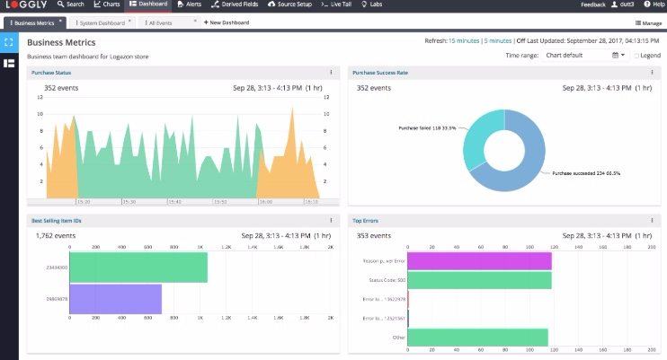

# GitHub Repository

<https://github.com/Sam-Marshall/Twenty_Years_Of_Flight>